Generating Environmental Assets Accounts

First Proof of Concept: ESA Land Use allocated Using Logistic Regression

FAME Economics

15 October 2025

# Background and context

The paper *Pacific Regional Environmental Accounts Incorporating Ocean Accounts* (1 August 2025) outlined a strategy for developing Regional Environmental Asset Accounts using satelite-based remote sensing data.

The plan was to build off Digital Earth Pacific (DEP) data foundation’s, reusing its geospatial metrics for data analysis, and incorporate FAME’s data sources to complete the following suite of accounts:

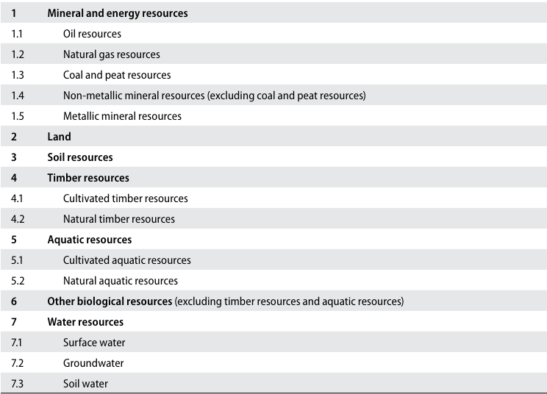

Figure 1: Classification of environmental assets in the SEEA Central Framework

This prototype work was undertaken to test *how* - on a very small scale - Pacific Regional Environmental Accounts might be developed within SPC. Using an extract from New Caledonia, the prototype work was intended to build a suite of Environmental Accounts, uncovering during the process issues and “fish hooks” which might impact on developing metrics at scale.

The R statistical language was used for the geospatial, logistical regression analysis, and the land cover prediction estimates.

## High Level Results

The focus of the prototype analysis become bogged down into estimating land-use metrics, in the absense of existing metrics developed through the DEP programme, and most of the effort associated with developing Environmental Asset Accounts related to measuring the land component, rather than the ocean component.

Ideally, land-use metrics would be developed from first principles using machine-learning techniques applied to satelite-based data. Simialar products developed internationally include New Zealand’s [LUCAS Land Use Maps](https://data.mfe.govt.nz/layer/117733-lucas-nz-land-use-map-2020-v005/), or Australia’s [National Scale Land Use Data](https://www.agriculture.gov.au/abares/aclump/land-use/data-download).

The prototype work was able to measure land cover area, and solve complicated methodological issues which hamper developing Environmental Asset Accounts at scale.

Figure 2 presents the predicted land cover values for Noumea, a subset of the prototype land area choosen for this analysis. The land cover values were derived from ESA CCI data measured at the 300 meter x 300 meter low resolution level, and grafted onto high resolution Sentinel-2 high measured at the 10 meter x 10 meter level.

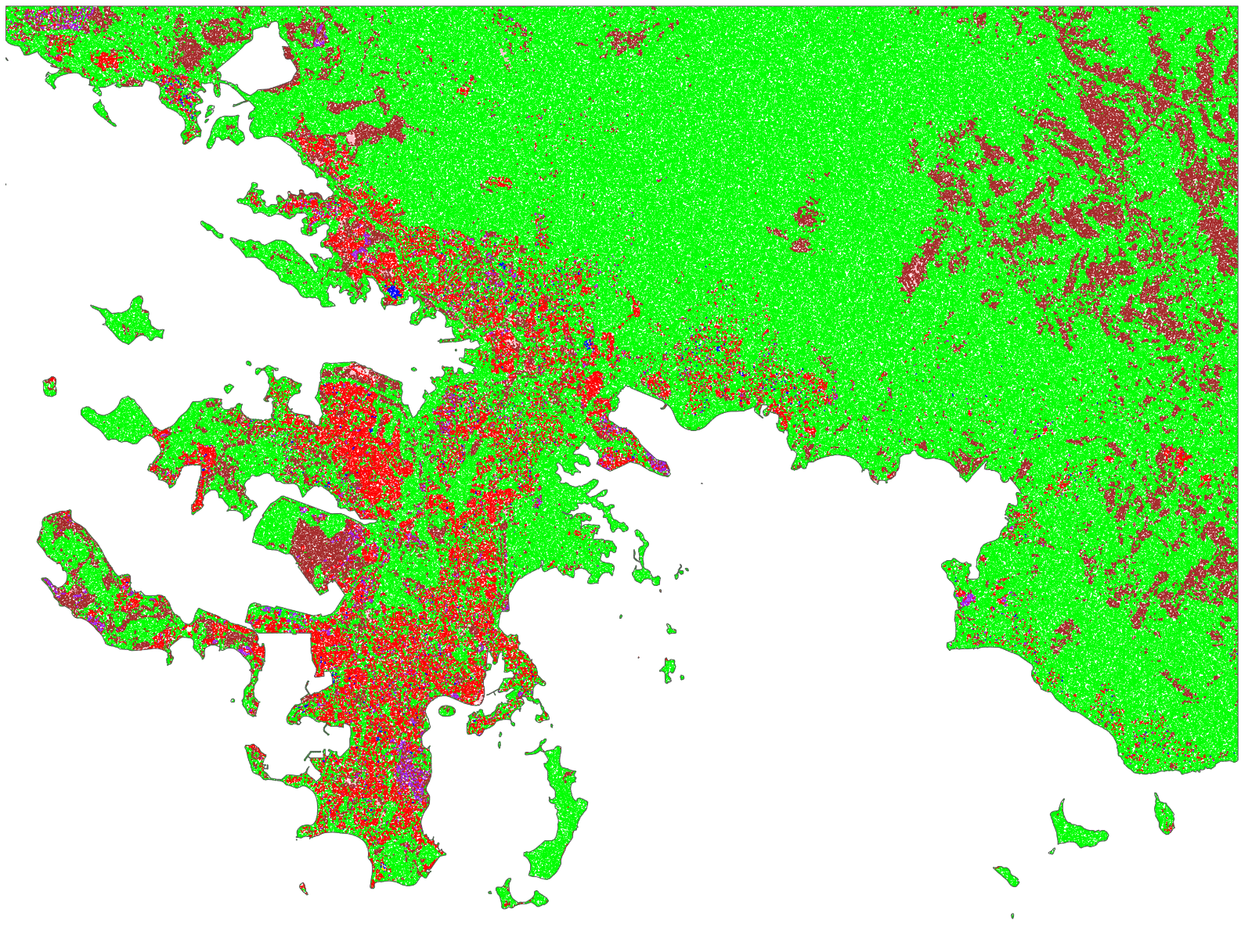A logistic regression for each land cover value was estimated using the Green / Blue / Red values from Sentinel-2’s [“Geometric Median and Median Absolute Deviations”](https://digitalearthpacific.org/#/applications) (GeoMAD) metrics supplied by DEP, matched to the ESA CCI land cover data associated with the specific Sentinel-2 area. The regression was only estimated for the 2017 year.

Figure 2: Estimated Land Use - Sentinel-2 Data

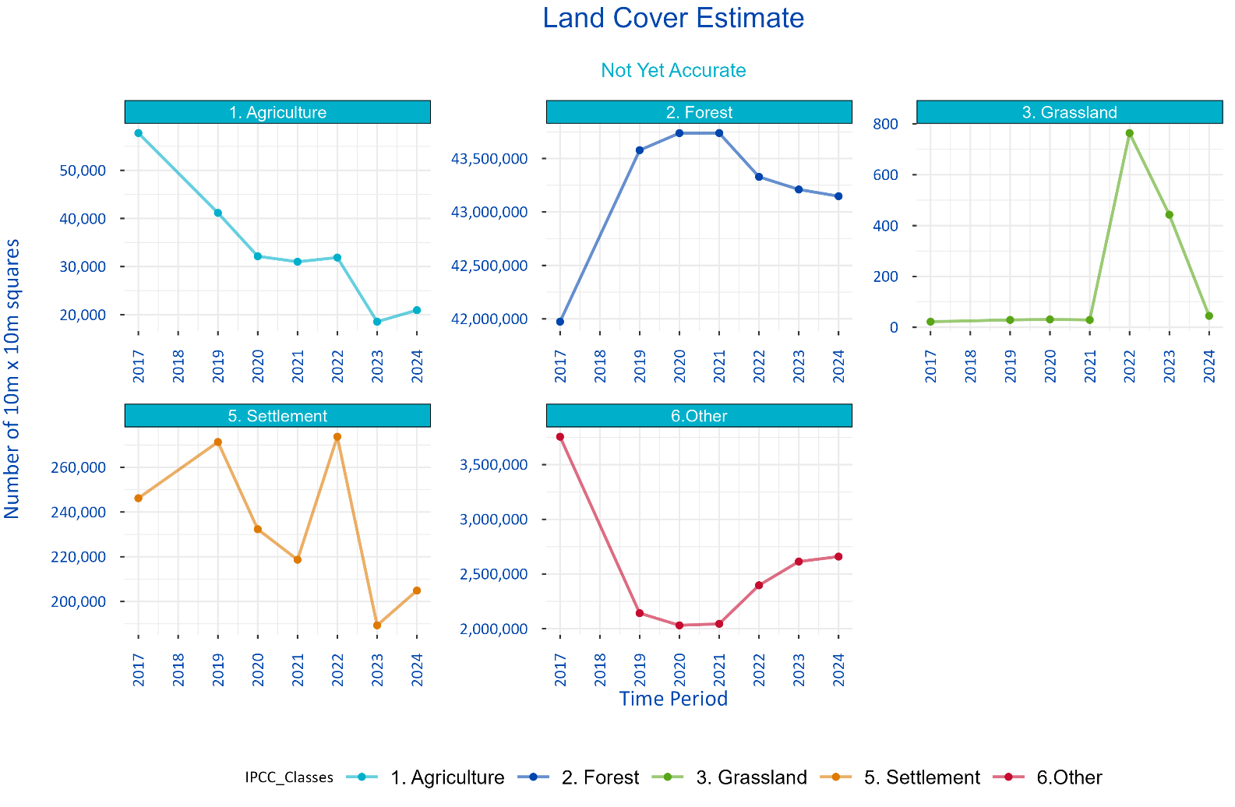The GeoMAD data source included a timeseries of spatial data from 2017 to 2024. The logistic regression from 2017 was applied to the out of sample years to estimate change Figure 2)

Figure 3: Experimental Land Use Metrics

One of the suggestions in the Learnings from Prototype Work section is to estimate each year independently to create the timeseries. The downside to this direction is the storage requirements associated with the duplication.

### Land cover is not land use

In the absense of home-grown land-use metrics, the European Space Agency’s (ESA) Climate Change Initiative (CCI) land use data was used to identify land use within the prototype area. ESA’s data measures land use according to the United Nations (UN) Land Cover Classification System (LCCS), described in Appendix 1 to this paper. The UN-LCCS defines LC classes using a set of classifiers. The system was designed as a hierarchical classification, which allows adjusting the thematic detail of the legend to the amount of information available to describe each LC class, whilst following a standardized classification approach.

There are two primary aspects of land for environmental accounting purposes: land use and land cover.

Physical land accounts focus on forest and other wooded land. Land use consists of seven main categories: agriculture, forestry, land used for aquaculture, use of built-up and related areas, land used for maintenance and restoration of environmental functions, other uses of land n.e.c. (not elsewhere classified), and land not in use. For inland waters, there are four main categories: inland waters used for aquaculture or holding facilities; inland waters used for maintenance and restoration of environmental functions; other uses of inland waters n.e.c.; and inland waters not in use.

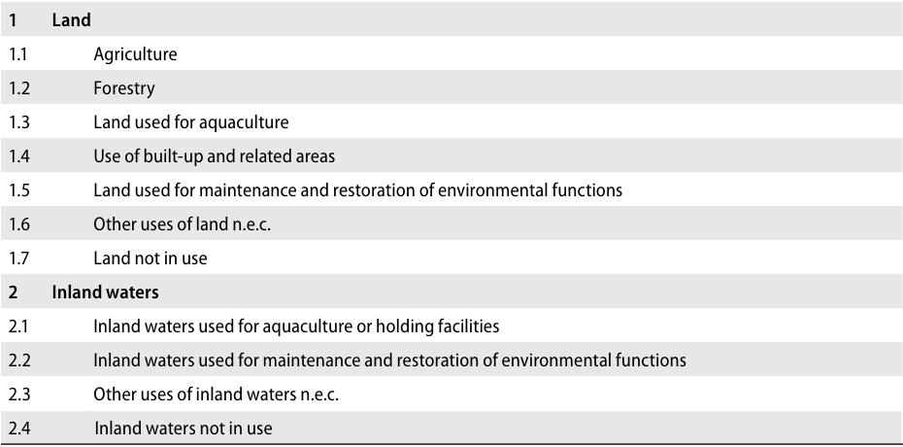

Figure 4: Land use classification

Using the ESA’s CCI’s data is compliant with the Land Cover Classification System version 3 recommended in SEEA-CF (see below).

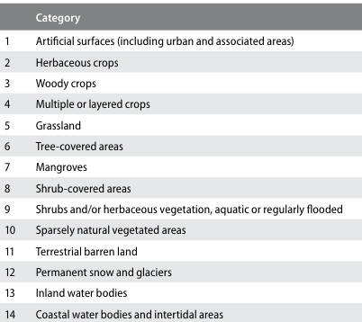

Figure 5: Land cover classification

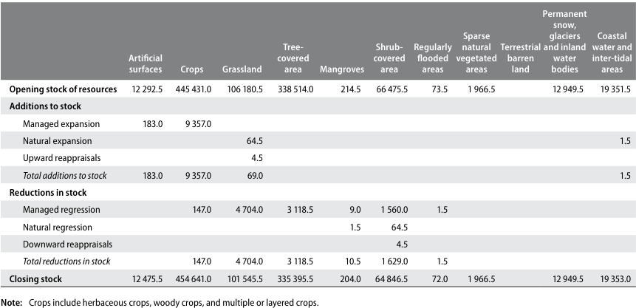

Figure 6: Physical account for land cover (hectares)

# Methodology

The prototype process involved extracting a portion of New Caledonia geography from two data sources:

1. European Space Agency’s (ESA) Climate Change Initiative (CCI) land cover data (<https://maps.elie.ucl.ac.be/CCI/viewer/download.php>)

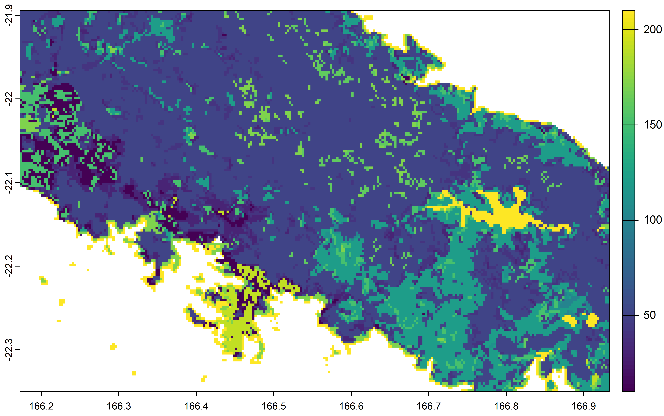

Figure 7: ESA Land Use Extract for Test Area

1. Sentinel-2’s [“Geometric Median and Median Absolute Deviations”](https://digitalearthpacific.org/#/applications) (GeoMAD) metrics supplied by DEP Satelite data is readily accessible in a variety of wavebands across the visible and non-visible spectrum. The [Sentinel-2 satelite constilation system](https://www.esa.int/Applications/Observing_the_Earth/Copernicus/Sentinel-2) collects 10 meter by 10 meter resolution images across four spectral bands every 5 days.[1]

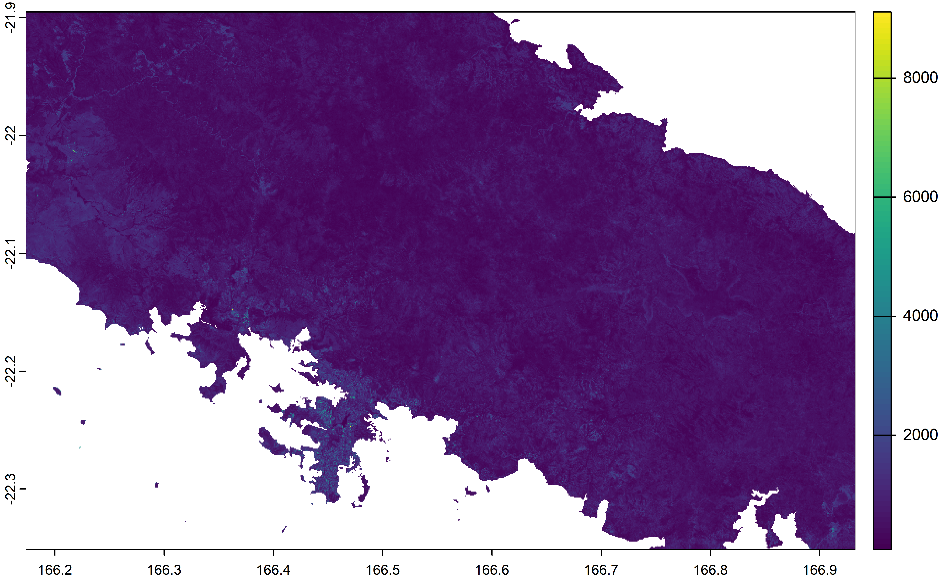

Figure 8: Sentinel-2 Red Colour Band

## Modelling low resolution land use to high resolution Sentinel-2 data

The 300 meter by 300 meter resolution ESA land use data, represented a consistently defined world measure, but was at a lower resolution than ideal. Specifically, Sentinel-2 data, which underpins DEP, operates at a 10 meter by 10 meter resolution across multple colour spectrums. A logistic regression approach was used to estimate the high resolution land use measures associated with the 10 meter by 10 meter pixels underneath the 300 meter by 300 meter ESA measiures

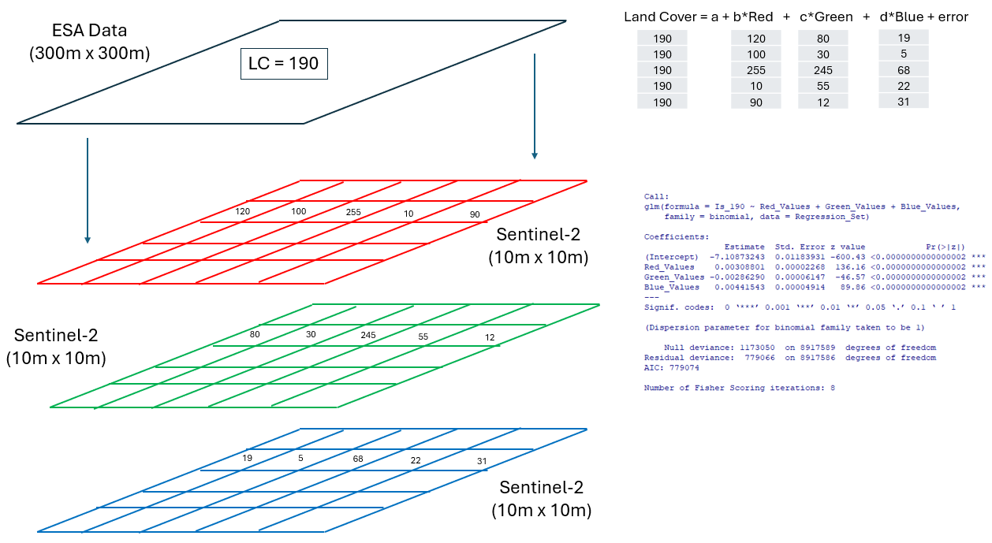

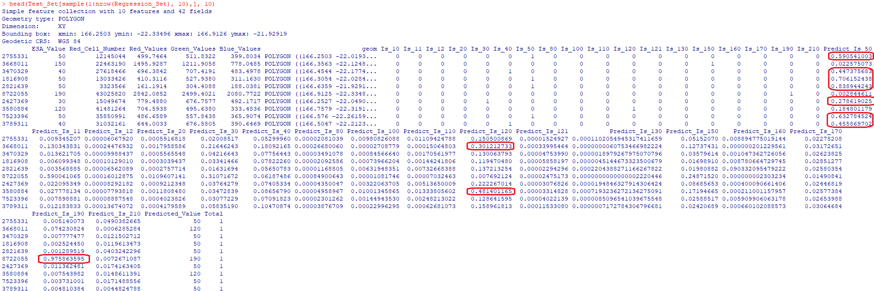Figure 9: Regression Set Up

Figure 10: Test Set

# Learnings from Prototype Work

Building prototype systems is about moving up a learning curve, continuously improving and refining. This project has followed this well-trodden. With the benefit of hindsight, changes would include:

*1. Moving away from PDH Pacific Coastline shape file, and adopting* [*DEP Coastlines*](https://data.digitalearthpacific.org/#dep_ls_coastlines/) *for defining the edges of countries*

To simplify the analysis, both the ESA and Sentinel-2 data used in the prototype was truncated to [PDH Pacific Coastline](https://geonode.pacificdata.org/catalogue/#/dataset/1712). The truncation meant that when sampling the spatial data to form both a regression and test data set, only land-based information was used in the analysis. Without truncation, Pacific Island Countries and Territories (PICTs), surrounded by ocean would have a random sample over-represented by sea-based observations.

The effect of truncation to the Coastline shape file has been to omit areas which are in that “in-between” places between sea and land. Figure 11 illustrates how mangrove areas have been truncated from the data.

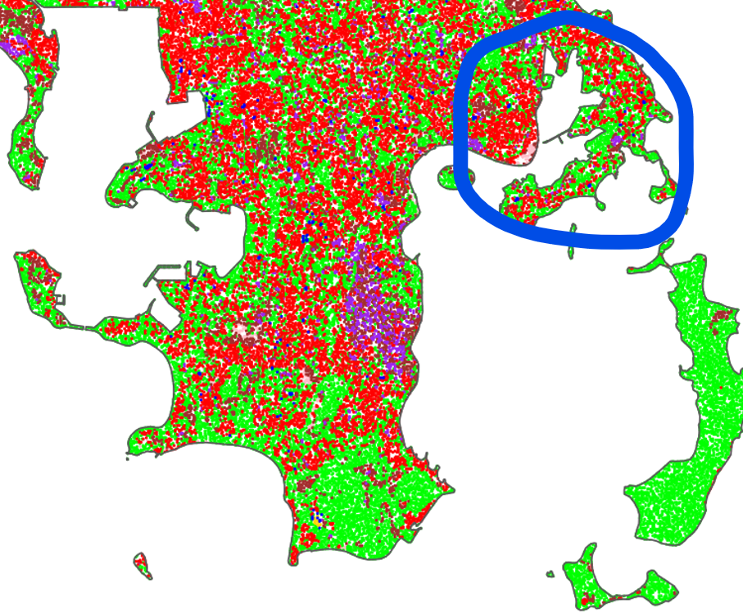

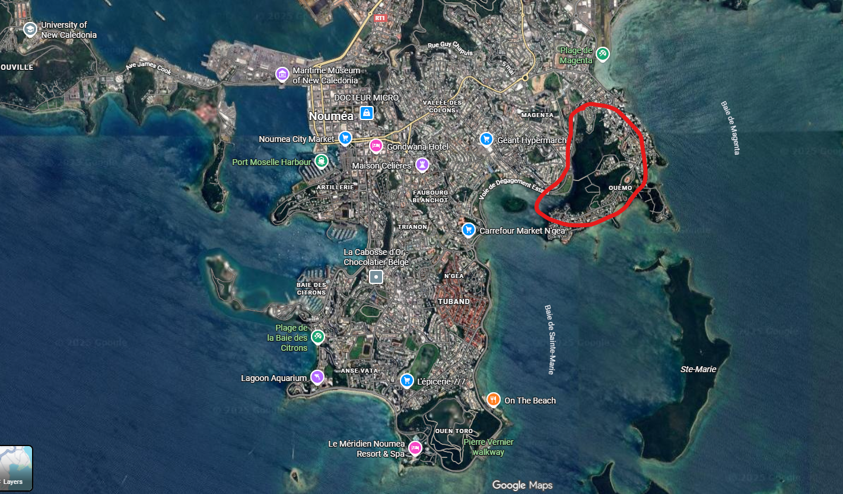

Figure 11: Pacific Coastlines truncates in-between Land and Water Areas

[DEP Coastlines](https://data.digitalearthpacific.org/#dep_ls_coastlines/) (the yellow line) look better (Figure 12).

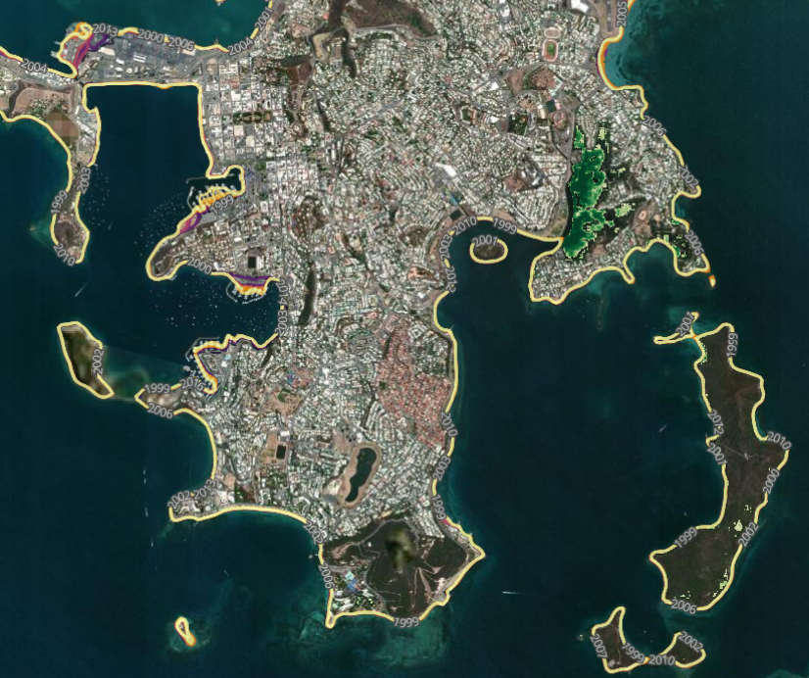

Figure 12: DEP Coastlines

*2. Adopting a more current ESA CCL data set.*

The ESA The land use data used in this analysis is “ESACCI-LC-L4-LCCS-Map-300m-P1Y-2015-v2.0.7.tif”, a 300 meter by 300 meter resolution land use mapping created for the entire world, with data as at year end 2015 - currently 10 years out of date. More up-to-date data is available, but not as readily accessible as the 2015 data set. Version 2.1.1, is available on an annual basis from 2016 to 2020, and is definitionally consistent with version 2.0.7 used in this analysis and would be a better data source for future work.

*3. Adopt a stratified random sample for the regression and test data sets*

Both the regression dataset, and the test dataset were derived through extracting two mutually exclusive simple random samples from the Sentinel-2 data matched to the its associated ESA land use value for the target prototype area.

Table 1, in the Appendix 1, describes all of the land uses available within ESA CCL dataset. Not all land values were available within the target prototype land area - the following land cover values were in the data:

| Land Cover Value | Description |
| --- | --- |
| 10 | Rainfed cropland |
| 11 | Rainfed cropland |
| 12 | Rainfed cropland |
| 20 | Irrigated cropland |
| 30 | Mosaic cropland (>50%) / natural vegetation (tree, shrub,herbaceouscover) (<50%) |
| 40 | Mosaic natural vegetation (tree, shrub, herbaceous cover) (>50%) / cropland (< 50%) |
| 50 | Tree cover, broadleaved, evergreen, closed to open (>15%) |
| 80 | Tree cover, needleleaved, deciduous, closed to open (> 15%) |
| 100 | Mosaic tree and shrub (>50%) / herbaceous cover (< 50%) |
| 110 | Mosaic herbaceous cover (>50%) / tree and shrub (<50%) |
| 120 | Shrubland |
| 121 | Shrubland |
| 130 | Grassland |
| 150 | Sparse vegetation (tree, shrub, herbaceous cover) |
| 160 | Tree cover, flooded, fresh or brakish water |
| 170 | Tree cover, flooded, saline water |
| 190 | Urban |
| 210 | Water |

Rather than a simple random sample, future work will explore drawing a stratified random sample with strata defined at both the country and the land cover level. A stratified sample draws a random sample from a population segregated by the stratum dimensions. If the data in the population contains unequal number of observations within the strata groupings, stratified sample ensures each different strata grouping contributes proportionally to the final analsys, regardless of its stratum size.

In the current prototype work, a 20% simple random sample produced a regression data set which was heavily influences by land cover 50 - “Tree cover, broadleaved, evergreen, closed to open (>15%)”

| Land Cover Value | Number of Observations | Proportion of Total |
| --- | --- | --- |
| 10 | 166,837 | 2% |
| 11 | 141,786 | 2% |
| 12 | 856 | 0% |
| 20 | 5,261 | 0% |
| 30 | 346,049 | 4% |
| 40 | 675,169 | 8% |
| 50 | 5,155,023 | 58% |
| 80 | 332 | 0% |
| 100 | 20,610 | 0% |
| 110 | 29,109 | 0% |
| 120 | 1,341,964 | 15% |
| 121 | 497 | 0% |
| 130 | 572 | 0% |
| 150 | 383,695 | 4% |
| 160 | 115,939 | 1% |
| 170 | 237,013 | 3% |
| 190 | 108,570 | 1% |
| 210 | 188,308 | 2% |
| Sample Totals | 8,917,590 | 100% |

While the simple random sample is unbiased - the population probably did contain 58% tree cover and might not have been the best choosen prototype area - extending the analysis across a number of countries might not generate the same efficient sample.

Multiple countries of different sizes and land uses, will bias a sample random sample towards land measures from the largest country, and the land uses which are most frequent across the countries. To compensate, a larger than normal sample is needed to ensure representation of smaller countries and areas.

Stratifying the regression sampling by both country and land use will ensure different countries and different size land use remain proportionally represented in the logistic regression. Done correctly the sample size can be reduced while at the same time the efficiency of the regression will be improved.

*4. Estimate land use regressions for each separate GeoMAD year* The prototype system estimated a logistic regression for each land use value for the 2017 and applied those metrics to 2017 - 2024.

The output of the regression modellings was a logistic regression object slightly larger than 1 gigabyte in size. Consequentially, estimating 18 separate land cover values for one year resulted in 18 separate one gigabyte regression model objects.

Extending the analysis to estimate regression objects for the years 2017 - 2024 would result in seven separate years of 18 separate one gigabyte regression model objects, consuming 126 gigabytes of disk space.

**Is there a better way to estimate a logistic regression object without including what is probably the underlying regression data?**

*5. Concord the spatial data back to a spatial grid system* The prototype system, developed in the R langauge, used the libraries raster, terra and sf for its geospatial analysis. Undoubtably, maintaining the geometries through the data added to the file size of the data objects.

A better approach would be to have treated the geospatial data as referencing consistently defined geospatially-specific grid measure which could be translated back into geospatial latitude and longitudinal dimensions, while at the same time enabling data to be more efficiently handled as data tensors, processed through matrices methods.

A variety of [“Geospatial grid management”](https://www.sciencedirect.com/science/article/pii/S1569843225005072) do exist.

I just need to get [cleverer](https://geobgu.xyz/r/matrices-and-rasters.html#rasters)…

# Appendix 1

Table 1: Land Use Categories

| IPCC Classes | IPCC Classes Detailed | Land Cover | Description |
| --- | --- | --- | --- |
| 1. Agriculture | 1. Agriculture | 10 | Rainfed cropland |
| 1. Agriculture | 1. Agriculture | 11 | Rainfed cropland |
| 1. Agriculture | 1. Agriculture | 12 | Rainfed cropland |
| 1. Agriculture | 1. Agriculture | 20 | Irrigated cropland |
| 1. Agriculture | 1. Agriculture | 30 | Mosaic cropland (>50%) / natural vegetation (tree, shrub,herbaceouscover) (<50%) |
| 1. Agriculture | 1. Agriculture | 40 | Mosaic natural vegetation (tree, shrub, herbaceous cover) (>50%) / cropland (< 50%) |
| 2. Forest | 2. Forest | 50 | Tree cover, broadleaved, evergreen, closed to open (>15%) |
| 2. Forest | 2. Forest | 60 | Tree cover, broadleaved, deciduous, closed to open (> 15%) |
| 2. Forest | 2.Forest | 61 | Tree cover, broadleaved, deciduous, closed to open (> 15%) |
| 2.Forest | 2. Forest | 62 | Tree cover,broadleaved, deciduous, closed to open (> 15%) |
| 2. Forest | 2. Forest | 70 | Tree cover, needleleaved, evergreen, closed to open (> 15%) |
| 2. Forest | 2. Forest | 71 | Tree cover, needleleaved, evergreen, closed to open (> 15%) |
| 2. Forest | 2. Forest | 72 | Tree cover, needleleaved, evergreen, closed to open (> 15%) |
| 2. Forest | 2. Forest | 80 | Tree cover, needleleaved, deciduous, closed to open (> 15%) |
| 2. Forest | 2. Forest | 81 | Tree cover,needleleaved, deciduous, closed to open (> 15%) |
| 2. Forest | 2. Forest | 82 | Tree cover, needleleaved, deciduous, closed to open (> 15%) |
| 2. Forest | 2. Forest | 90 | Tree cover, mixed leaf type (broadleaved andneedleleaved) |
| 2. Forest | 2. Forest | 100 | Mosaic tree and shrub (>50%) / herbaceous cover (< 50%) |
| 2. Forest | 2. Forest | 160 | Tree cover, flooded, fresh or brakish water |
| 2. Forest | 2. Forest | 170 | Tree cover, flooded, saline water |
| 3. Grassland | 3. Grassland | 110 | Mosaic herbaceous cover (>50%) / tree and shrub (<50%) |
| 3. Grassland | 3.Grassland | 130 | Grassland |
| 4. Wetland | 4. Wetland | 180 | Shrub or herbaceous cover, flooded, fresh-saline or brakish water |
| 5. Settlement | 5. Settlement | 190 | Urban |
| 6.Other | 6.1 Shrubland | 120 | Shrubland |
| 6.Other | 6.1 Shrubland | 121 | Shrubland |
| 6.Other | 6.1 Shrubland | 122 | Shrubland |
| 6.Other | 6.2 Sparse Vegetation | 140 | Lichens and mosses |
| 6.Other | 6.2 Sparse Vegetation | 150 | Sparse vegetation (tree, shrub, herbaceous cover) |
| 6.Other | 6.2 Sparse Vegetation | 151 | Sparse vegetation (tree, shrub, herbaceous cover) |
| 6.Other | 6.2 Sparse Vegetation | 152 | Sparsevegetation (tree, shrub, herbaceous cover) |
| 6.Other | 6.2 Sparse Vegetation | 153 | Sparse vegetation (tree, shrub, herbaceous cover) |
| 6.Other | 6.3 Bare Area | 200 | Bare areas |
| 6.Other | 6.3 Bare Area | 201 | Bare areas |
| 6.Other | 6.3 Bare Area | 202 | Bare areas |
| 6.Other | 6.4 Water | 210 | Water |

1. Sentinel-2 collects four bands at 10 m, six bands at 20 m, and three bands at 60 m spatial resolution. <https://dataspace.copernicus.eu/data-collections/copernicus-sentinel-data/sentinel-2>